CREATED BY:

SOMYA TYAGI

MALAV DESAI

PRACHI PRACHI

JASHANPREET KAUR

WINGMAN INFLUENCERS.

Trendsetters Technologies

Contents

BUSINESS CASE 3

Who we Are 3

Our team 3

Business Need 4

VISION 5

Benefits over Traditional Marketing system: 5

a) Creators can help you reach the right audience: 5

b) It’s accessible to businesses of all sizes: 5

c) It can boost your SEO rankings 6

d) Money saving: 6

Budget 7

1 - Estimation on team members to be hired 7

2 - Initial Investment: 7

3 - Monthly Investment during the development: 8

Product Vision 9

**Be yourself, be an inspiration!** 9

MOBILE DEVICE LAYOUT 10

WEBPAGE LAYOUT 11

12

Product Personas 13

KATRINA 13

ROHIT 13

BRAND STORY 14

MAMAEARTH 14

KRAFT HEINZ 14

Product Scope 15

SMART GOALS 16

UML 17

Cases diagram 18

Product Roadmap 19

Development Roadmap 19

Development Gant Chart 20

Kanban Board 21

Appendix 22

Trello Board Link 23

## BUSINESS CASE

## Who we Are

Every Influencer has a place on our platform, We help our clients to connect with each other

to build an ecosystem for Influencers and the Brands. We categorise our influencers in three ways - on the basis

of platform, category, and number of followers. We believe that Technology helps increase the efficiency of systems,

products and services, and that is why we created this platform- WINGMAN INFLUENCERS.

### Our team

Soumya Tyagi

Product Owner

Student, College LaSalle

Malav Desai

Development manager

Student, College LaSalle

Prachi Prachi

Scrum master

Student, College LaSalle

Jashanpreet Kaur

Developer

Student, College LaSalle

# Business Need

"Ignoring online Marketing is like opening a Business but not telling anyone"

The Traditional Marketing system's failure to adapt to contemporary technologies, lack of

immediacy, harder approach to target audience, lack of innovation and higher price points are some of the points

why the Brands are adopting Influencer Marketing.

Additionally, apart from being more expensive, traditional marketing is often ineffective because most

people ignore it because mostly it lacks innovation and creativity. Even if they buy your product, It's impossible to

calculate the sales conversion rates through traditional marketing. The 3 objects of Influencer Marketing are-

reach, engagement and conversion, with the help of Influencer Marketing, you can easily calculate all three.

Using an Influencer Marketing platform aims to speed up your Marketing Projects as we keep the deadline of 15

days for the whole execution of the Project. In the long run, Marketing expenses will also go down. By being able

to independently market your Brand from any location all over the country, Brands can save time and money.

# VISION

"An ecosystem for Social media Influencers and Brands"

Influencer Marketing is a system that targets social media Influencers and Brands, small-to-large brands,

micro-to-macro-Influencers.

Wingman Influencers is the platform that elements middleman from the whole process and directly connects

the brand and the Influencers without charging heft commissions on each project.

The Influencer Marketing system is a platform which saves time, money and effort needed to make television and newspaper

advertisements.

## Benefits over Traditional Marketing system:

### a) Creators can help you reach the right audience:

As third-party cookies go away, marketers lose access to powerful

tracking data, making reaching target audiences through advertising much more difficult.

However, when you work with creators, you can check out their followers to know

exactly who you’ll be reaching. Creators have access to some demographic data from the

social media platforms they post on, and they may be willing to share it if you reach out.

### b) It’s accessible to businesses of all sizes:

One of the best qualities of influencer marketing is that it is suitable for any business

regardless of size or industry. If someone is influential in your vertical, you can

always leverage them for your marketing. Plus, if you’re a small business with a small marketing

budget, nano and micro influencers partnerships aren’t too pricey.

c) It can boost your SEO rankings:

If you want more organic traffic from search engines (but, who isn’t?), influencer

marketing can boost your SEO efforts. Earning links to your website from other high-quality sites

can tell search engines that your content is good, which can lead to higher rankings. So, if you partner

with bloggers and have them link to your site in posts about you, your site could potentially earn top

spots on search results pages.

### d) Money saving:

Influencer marketing is the cheapest from of marketing with numerous benefits.

Even small start-ups can afford influencer marketing and brands won't have to spend thousands of

dollars for advertisements.

By using Influencer Marketing platform we take care of environment.

By adopting Influencer marketing and going digital, we are saving tons of kgs of plastic advertisement

waste, plastic hoardings, plastic and paper banners, helping to encourage responsible behaviour in

companies and organisations. Additionally, Brands have the opportunity to market their brand comfortably from

anywhere in the world without any extra costs of advertisements shootings.

# Budget

The initial investment for our Wingman Influencer is describe below:

### 1 - Estimation on team members to be hired

### 2 - Initial Investment:

76,400 – 80,000 CAD

### 3 - Monthly Investment during the development:

Monthly Fixed Expenses - 72,000.00 CAD



We are estimating an 26 weeks or 6 month development period that will give the total investment of:

512,000. CAD

## Product Vision

## **Be yourself, be an inspiration!**

Wingman Influencer targets all categories of bloggers, influencers and the companies for the marketing.

Wingman Influencer is the platform which eliminates middlemen and directly connects the brands and the influencers.

By using our platform both the influencers and the brands will not be exploited anymore, as the bloggers and influencers can connect with the brand directly without paying any hefty amounts to the middlemen and the brand can also get quality content and target the perfect audience.

Here are some benefits of using our platform –

1) no commission- Bloggers and    influencers can get collaborations without paying any commissions to the middlemen.

2) efficient marketing

Brand can do marketing on various social media platforms without spending thousands of dollars, by directly collaborating with out influencers on the app.

3) target perfect audience-

The brands can choose their own bloggers to work on the collaboration and hence can target the audience of their choice. (gender, age, city)

4)increased sales

Influencer affiliated marketing is proven to increase the sale of the company, as the audience connect with the bloggers, so they eventually buy the product.

## MOBILE DEVICE LAYOUT

# WEBPAGE LAYOUT

# Product Personas

### KATRINA

* demographics
* 21 years old
* -goes to college
* -lives in Montréal
* -loves fashion and clicking photos

behaviours

* -loves making fashion videos
* -earns by collaborating with fashion brands
* -grows her followers by collaborating with brands

**needs**

* I wish I didn't have to pay commissions to the middlemen
* I wish I could get more brand collaborations
* I wish I could connect with brands directly and learn more about fashion collaborations

### ROHIT

-45 years old

-travel blogger

-lives in vancouver

-loves to travel

behaviours

* -uses instagram to share his travel videos
* -gives hotel,food and shopping guidance to his followers
* on his instagram page for every country he visits
* -makes hotels review videos to get free vouchers from the hotel.

NEEDS

* -dont know how to get more collaborations from hotels and flights.
* wishes there was an app where he could directly collaborate with the hotels and travel companies.
* -wishes he could earn by travel blogging.

## BRAND STORY

### MAMAEARTH

* -cosmetic brand for women,children,men'
* -100% natural products
* -safe products for babies

behaviours

* -makes products for the babies and women majorly
* -is available all over the world
* -wants to make awareness about its 100% natural products

NEEDS

* -wishes there was an app to find bloggers off all age, gender and origin under one roof.
* dont know how to connect with bloggers directly and do social media marketing
* -wishes to hire baby bloggers to promote its baby products but dont know how to do.

### KRAFT HEINZ

* -food brand which produces more than 170 products.
* -affordable food products

behaviours

* -uses its own instagram page to do social media marketing
* -spends thousands of dollars every month on social media marketing with zero impact
* because doesn't know how to connect with the influencers directly.
* -targets wrong audience because cant reach the exact audience

NEEDS

* -wish there was a way to find all the food bloggers under one roof
* -wish there was a way to find the genuine influencers and not the bloggers with fake followers
* -wish there was a way to target the perfect audience to increase sales by affiliated marketing

# Product Scope

It is the scope of the product to build an ecosystem for Influencers and Brands

through a web application, the possibility for Influencers to grow their businesses

in a secure and organised way.

* create a user Influencer account
* Link your Social media IDs to your user account
* search for the compatible business
* Connect through chat box and finalise the project.
* Accept payments from brands and complete the project
* Give Analysis report to the Brand.

Regarding the Brand, the software must provide:

* Create a Brand marketing profile
* Update details regarding the project.
* -Search for compatible Influencers
* -Connect with them through Chatbot.
* -Send secure and safe transactions to the Influencers through the website.
* -collect the Analysis report from the Influencers.

## SMART GOALS

SPECIFIC

We want to build an convenient,reliable and accessible Influencer Marketing App

with a friendly user interface that can connect both the parties- Influencer and the Brand

so that the Brand can Market their products in the most cost-effective way,recieve

more inbound traffic,and earn highest ROI than other marketing channels and the Influencers

can grow their businesses by collaborating with the best brands.

MEASURABLE

By dividing the entire system into small tasks known as user histories, we can track the

development processes of the system using burn down charts during each iteration of the

team.

ACHIEVABLE

We will use scrum as an agile approach to track all the iterations and deliverables

according tot he user story tasks.

RELEVANT

We want to replace the unorganised and biased influenecer marketing system with a fully

automated and efficient system that provides the best platform for both the parties to

collaborate and create the magic.

TIME BOUND

After the approval of the project, we want to achieve the first project after 2 months of the

release.

## UML

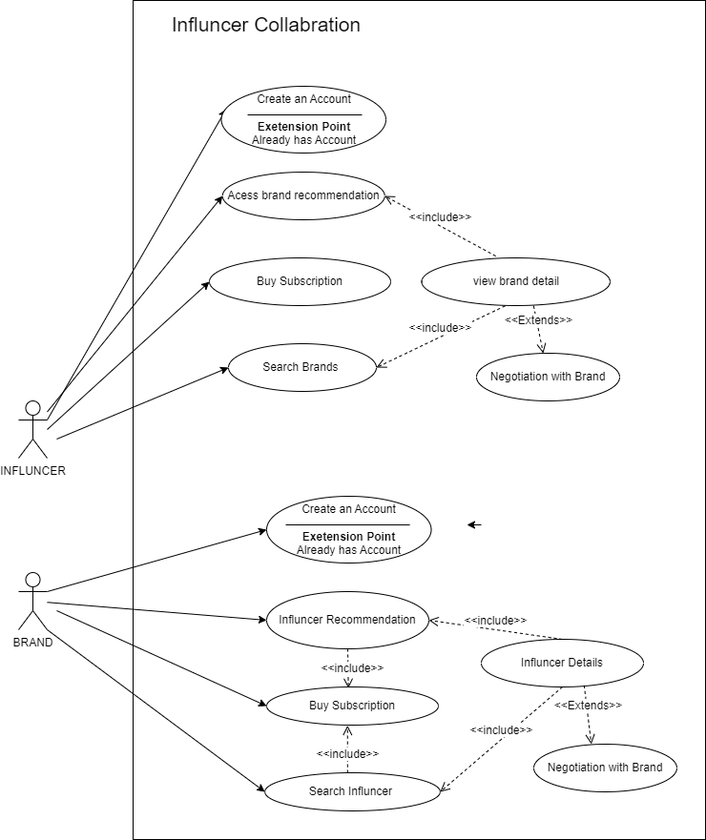

# Cases diagram

# Product Roadmap

JAN 2023 FEB 2023 MAR 2023 APR 2023 MAY2023

## Timeline Description automatically generatedDevelopment Roadmap

JAN 2023 FEB 2023 MAR 2023 APR 2023 MAY 2023

## Development Gant Chart

# Kanban Board

# Appendix

Team charter

## Trello Board Link

https://trello.com/invite/b/64vElXqK/ATTId4c11d91659795e4307ef09142455ec4D8AB5243/personas